DEEP LEARNING
Preprocessing.

Image preprocessing consists of a manual crop performed by doctors to select the proper region of the input ecography. These crops have different sizes, ranging from 40 to 100 pixels per side. A random crop and resizing is performed on the manual crops to have a fixed size of 224x224, as expected by ImageNet pretrained models. Also, a random flip in both directions is added. Finally, image pixels are normalized using a fixed mean and standard deviation determined by ImageNet pretraining.

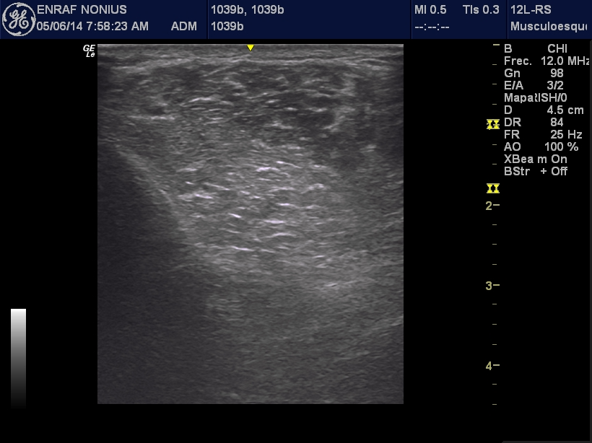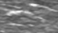

CNN
FC
Overview of the process. Marked in red manual crop selection. Several patches are extracted for each manual crop during preprocessing as a data augmentation.

DCNN architectures.

Three different DCNNs (VGG16, ResNet-50, and DenseNet121) were used to classify muscle images to measure the efficacy of the DCNNs. The pre-trained weights of all models were obtained from training a subset of ImageNet dataset—a large scale benchmark dataset that contains 1.28 million natural images with 1000 categories. The saved DCNN models were then fine-tuned with our training dataset after replacing the final fully connected and softmax layer with a new fully connected layer and a random initialized sigmoid layer. The training for all the models was performed using a mini-batch gradient descent with SGD optimizer. For each backend, Ray Tune hyperparameter optimization library was used to find best hyperparameters (Table 1). Pretrained DCNN models were imported from TIMM image models library, using Pytorch deep learning framework for all model training (version 1.12)

DCNN | Learning rate | Momentum
Resnet50 | 0,06 | 0,005
VGG16 | 0,01 | 0,014
DenseNet121 | 0,04 | 0,007
Table 1: Hyperparameters used for each backend

Results

All DCNN’s were evaluated using the same methodology. After best hyperparameters are found with Tune library, a 10 fold cross validation is run using different training and test subjects, keeping 80% of subjects for training and the rest for evaluation. For each cross validation iteration, a classifier is trained using best hyperparameters and accuracy per image is reported. After classifying each subject image, a majority vote is used to classify each subject. Results are reported in table 2.

DCNN | Mean accuracy per image | Mean accuracy per subject
Resnet50 | 78,8% | 90%
VGG16 | 81,4% | 94%
DenseNet121 | 78,9% | 89%
Table 2: Mean accuracy per image and per subject for each DCNN

Discussion

Due to the low number of images (52 subjects, 8 images per subject), dataset training is difficult. It can be seen that accuracy per subject for all models in cross validation oscillates between 81% and 100%, so accuracy is heavily influenced by certain difficult subjects. One solution to this is to extend dataset with more subjects. Also, pretraining on an ecography dataset will increase stability.
Among the three DCNNs, we can see that VGG achieves best results. VGG is a network specially suited for textural analysis, so it is logical that this network achieves best accuracy per image and per subject.

BIBLIOGRAFIA

Karen Simonyan, Andrew Zisserman, “Very Deep Convolutional Networks for Large-Scale Image Recognition”, Computer Vision and Pattern Recognition (CVPR) (2014)

Kaiming He, Xiangyu Zhang, Shaoqing Ren, Jian Sun, “Deep Residual Learning for Image Recognition”, Computer Vision and Pattern Recognition (CVPR)
(2015)

Gao Huang; Zhuang Liu; Laurens Van Der Maaten; Kilian Q. Weinberger, “Densely Connected Convolutional Networks”, IEEE Conference on Computer Vision and Pattern Recognition (CVPR), 2017

Liaw, Richard and Liang, Eric and Nishihara, Robert and Moritz, Philipp and Gonzalez, Joseph E and Stoica, Ion, “Tune: A Research Platform for Distributed Model Selection and Training”, arXiv preprint arXiv:1807.05118, 2018

Ross Wightman, “PyTorch Image Models”, GitHub repository, 2019

Paszke, Adam and Gross, Sam and Massa, Francisco and Lerer, Adam and Bradbury, James and Chanan, Gregory and Killeen, Trevor and Lin, Zeming and Gimelshein, Natalia and Antiga, Luca and Desmaison, Alban and Kopf, Andreas and Yang, Edward and DeVito, Zachary and Raison, Martin and Tejani, Alykhan and Chilamkurthy, Sasank and Steiner, Benoit and Fang, Lu and Bai, Junjie and Chintala, Soumith, “PyTorch: An Imperative Style, High-Performance Deep Learning Library”, Advances in Neural Information Processing Systems 2019

MACHINE LEARNING
Preprocessing.

Image preprocessing is applied to the same regions of interest (ROIs) as discussed before of the input images. In this case ROIs are not resized. For each ROI local binary pattern (LBP) [1], gray level co-occurrence matrices (GLCM) [2], and gray level run lengths matrices (GLRLM) [3] were calculated. LBP and GLCM were computed using Scikit Image [4]. GLRLM has its own Python library for its implementation [5]. For classification, features are extracted from these computations. For LBPs, a 10 bin normalized histogram is computed, generating a feature vector of size 10. Regarding GLCMs 5 texture properties were extracted; dissimilarity, contrast, ASM, energy and correlation [6]. For GLRLM also 5 features were obtained: Short Run Emphasis (SRE), Long Run Emphasis (LRE), Gray Level Uniformity (GLU), Run Length Uniformity (RLU) and Run Percentage (RPC).

%En esta sección si hace falta se puede ampliar más la descripción de la extracción de características, pero no creo que sea el foco del artículo%

Results.
In order to see which texture descriptors provide more information for ROIs, different random forests [7] were hypertuned and trained for each texture descriptor. Also, all previously computed descriptors and previously obtained features (no explico los features que nos dió Jose porque entiendo que el lo explica en otro lado, a lo mejor citar el artículo donde lo explica??) are also used to see if classification accuracy increases with all features.
In order to perform a random forest parameter optimization, first a randomized search [8] is undergone to narrow down hyperparameter values. This is followed by a grid search to obtain the best parameters which are shown in table 3.

Parameter | LBP | GLCM | GLRLM | All features
Bootstrap | False | False | False | False
max_depth | None | None | None | None
max_features | sqrt | sqrt | sqrt | sqrt
min_samples_leaf | 2 | 1 | 3 | 1
min_samples_split | 8 | 6 | 8 | 5
n_estimators | 1800 | 800 | 700 | 500
Table 3: Hyperparameters for each random forest for each selection of features.

 | LBP | GLCM | GLRLM | All features
Mean accuracy | 0.77698 | 0.78344 | 0.70369 | 0.89316
Mean std 𝝈 | 0.11124 | 0.09778 | 0.11510 | 0.07731
Table 4: Mean accuracy per image for each selection of texture descriptors. Mean accuracy has been computed from averaging ten 10-fold cross validations.

Discussion.

Although classical texture analysis does not require as much data as the previous approach (Deep Learning), the number of images is still low [9]. If dataset size increased it would result in an improvement on overall results. Data augmentation techniques were not used in this section. This could be done to increase the size of the data set, hence improving the algorithms’ performance. Also different classification algorithms (e.g.: SVM, kernel SVM, Naïve Bayes…) could be used and results compared to search for the best possible classification algorithm in this situation. As expected, when all texture descriptors are used the best results are obtained, also obtaining the lowest standard deviation (std). GLRLMs are the worst performing texture features. LBPs and GLCMs perform the best by themselves, with GLCMs being a little bit better than LBPs. Due to the small amount of data, classical machine learning methods perform better deep learning architectures presented in the previous section.

References.

- Ojala, T.; Pietikäinen, M.; Harwood, D. A comparative study of texture measures with classification based on featured distributions. Pattern Recognit. 1996, 29, 51–59.
- Haralick, R.M.; Dinstein, I.; Shanmugam, K. Textural Features for Image Classification. IEEE Trans. Syst. Man Cybern. 1973, SMC-3, 610–621.
- Galloway, M.M. Texture analysis using gray level run lengths. Comput. Graph Image Process 1975, 4, 172–179.
- Stéfan van der Walt, Johannes L. Schönberger, Juan Nunez-Iglesias, François Boulogne, Joshua D. Warner, Neil Yager, Emmanuelle Gouillart, Tony Yu and the scikit-image contributors. scikit-image: Image processing in Python. PeerJ 2:e453 (2014) https://doi.org/10.7717/peerj.453
- Muhammad Razif Rizqullah, “eiproject/python-glrlm”, GitHub repository, 2019
- M. Hall-Beyer, 2007. GLCM Texture: A Tutorial v. 1.0 through 3.0. The GLCM Tutorial Home Page, https://prism.ucalgary.ca/handle/1880/51900 DOI:10.11575/PRISM/33280
- Breiman, “Random Forests”, Machine Learning, 45(1), 5-32, 2001
- Random Search for Hyper-Parameter Optimization James Bergstra, Yoshua Bengio; 13(10):281−305, 2012.
- Alom, Md. Zahangir & Taha, Tarek & Yakopcic, Chris & Westberg, Stefan & Sidike, Paheding & Nasrin, Mst & Hasan, Mahmudul & Essen, Brian & Awwal, Abdul & Asari, Vijayan. (2019). A State-of-the-Art Survey on Deep Learning Theory and Architectures. Electronics. 8. 292. 10.3390/electronics8030292.

Tengo tambien fotos de mean accuracies por cada run
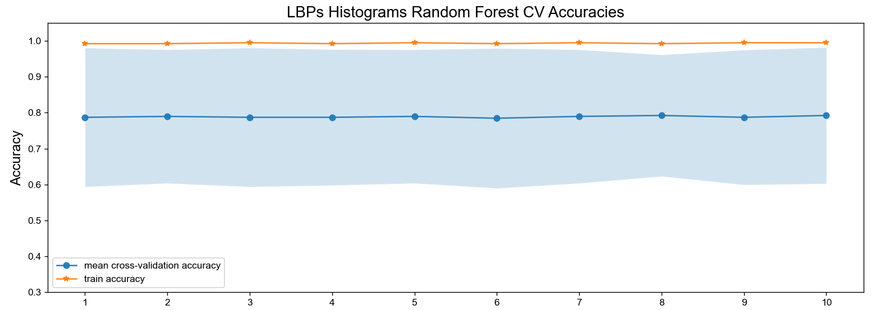
Y también confusion matrix por cada feature para recall, precision i F1, pero si añadía todo esto se extendía demasiado desde mi parecer, pero ya me decis si quereis que lo añada
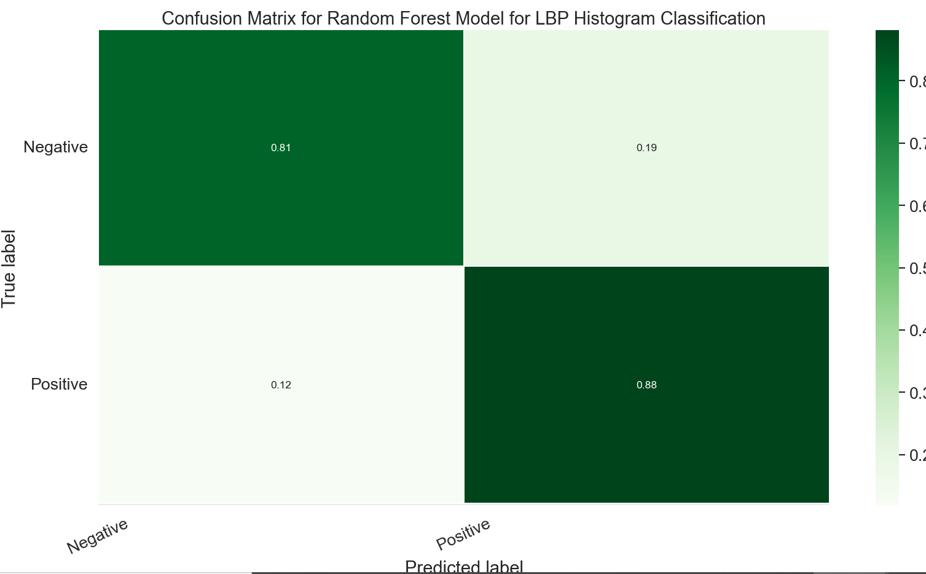

O fotos como esta para ayudar a su comprensión, pero como el artículo que utilizamos no entra en mucha profundidad tampoco lo he hecho
